Viewing the captured images in HydroView externally
The captured images from a HydroView test can be examined externally (ie, on a PC/Laptop etc.) by the following methods:
- Export the raw test result
Refer to the operator guide on saving test results.
To access the captured images, however, use the save to USB option:
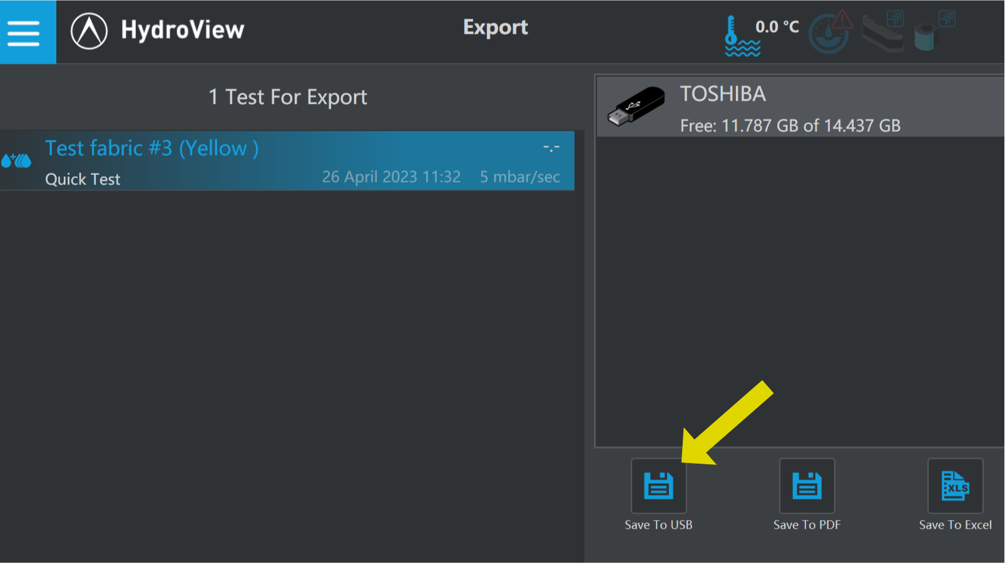
Once exported, the USB drive can be inserted into a PC and the test file will be saved along with all captured images in .PNG file format:
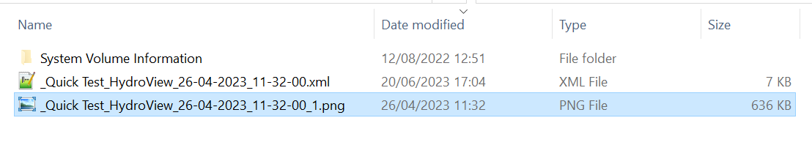
*Note that the auto-generated image file names will correspond to the test .xml file name eg:
TestFile_With_Date.xml
TestFile _With_Date_1.png
TestFile _With_Date_2.png
TestFile _With_Date_3.png
…
TestFile123_With_Date.xml
TestFile123_With_Date_1.png
TestFile123_With_Date_2.png
TestFile123_With_Date_3.png
TestFile123_With_Date_4.png
…

- Have the captured images embedded in the report PDF file
In report settings, press the Edit button on the currently active setup: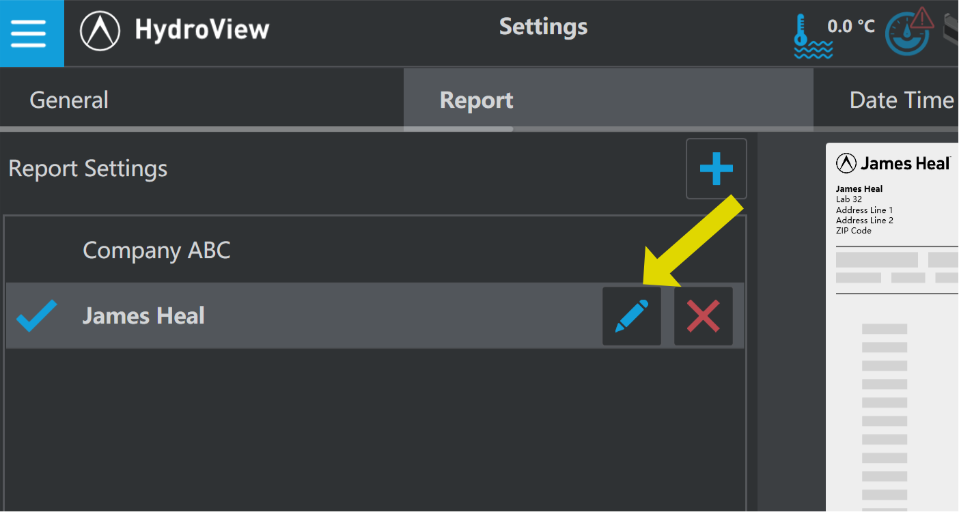
Make sure the option to Include Captures is turned on:
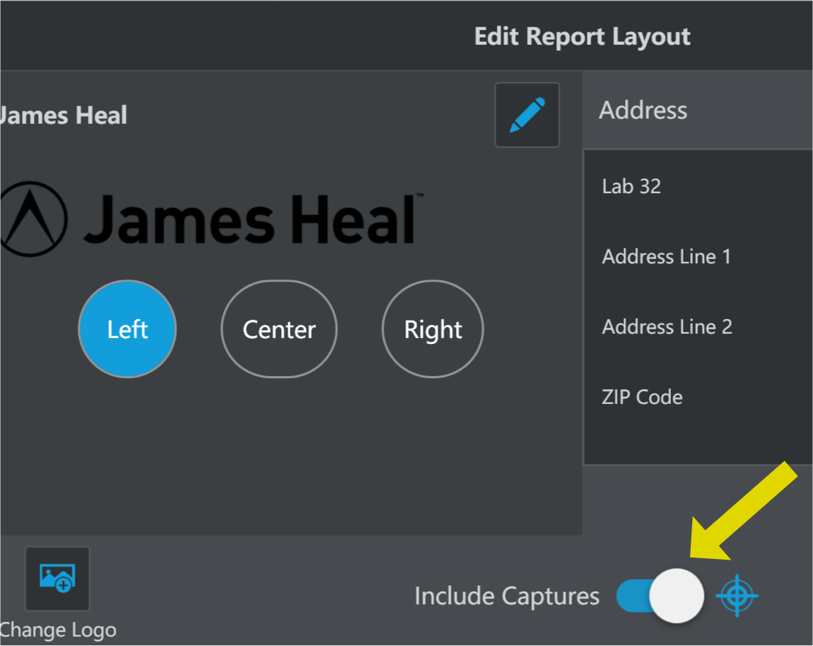
Now, when a PDF report is created, the image captures are added to the file: